Generalized Girder Haunch Depth

Introduction
This document details a generalized method for computing the required girder haunch depth for a precast prestressed girder. The haunch depth is known as the “A” Dimension in WSDOT jargon.

Each geometric effect is considered independently of all others. The total geometric effect is the algebraic sum of each individual effect.

Notation
The following notation is used throughout this document
x_{i} | = | Station at section i
z_{i} | = | Normal offset from alignment to centerline of the girder at section i
y_{a}(x_{i},z_{i}) | = | Elevation of the roadway surface at station x_{i} and normal offset z_{i}.

Deck Effect
The distance between the top of the girder and the top of the roadway surface, must obviously be at least the thickness of the roadway slab plus any fillet and haunch.
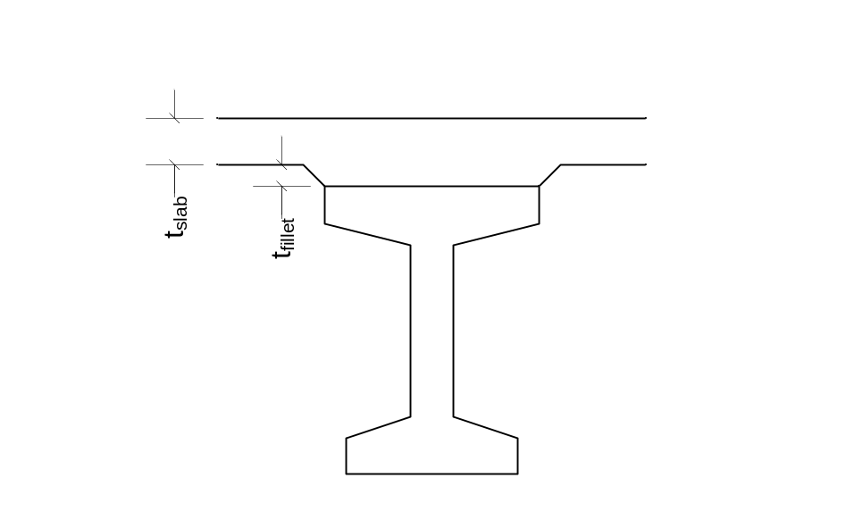
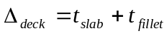

Excessive Camber Effect
The girder haunch must be thickened to accommodate any camber that remains in the girder after slab casting.

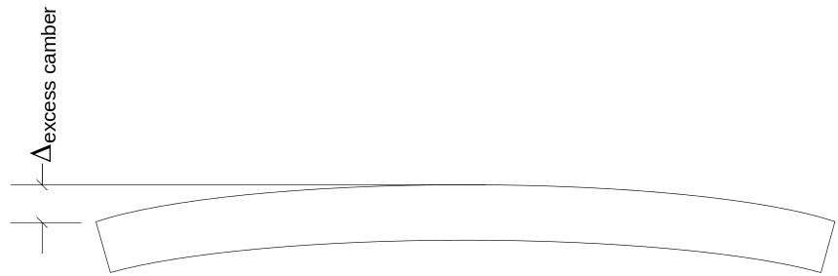

Profile Effect
The profile effect accounts for changes in the roadway profile along the length of the girder. Profile changes include grade changes, vertical curve effects, offset deviations between the centerline of girder and the alignment caused by flared girders and/or curvature in the alignment. This is a generalized form of the Vertical Curve Effect and the Horizontal Curve Effect combined.

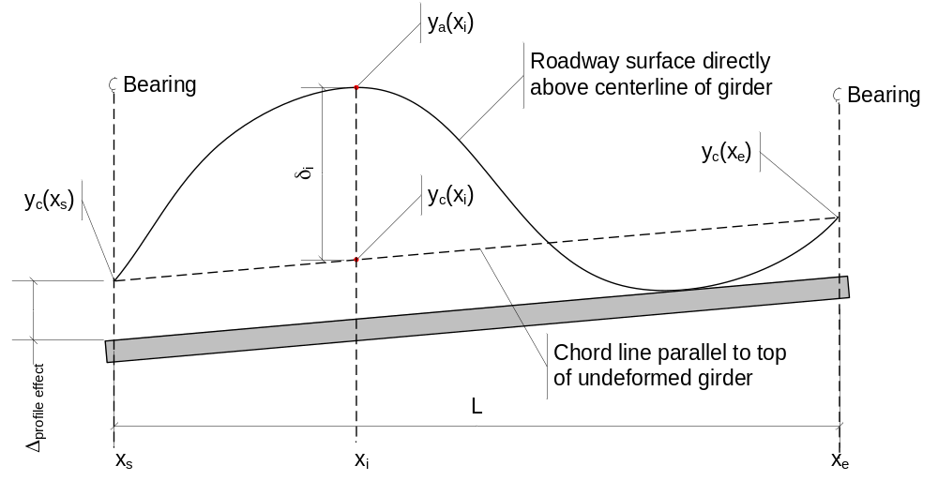

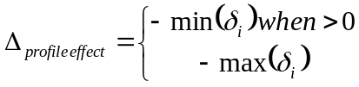 is the profile effect where:

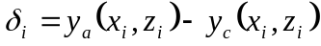 is the difference between the roadway surface directly above the centerline of the girder and a chord line, parallel to the top of the girder (ignoring camber effects), connecting the points defined by the intersection of the centerline of bearing and the roadway surface.
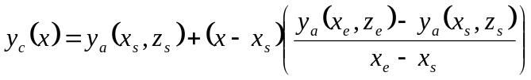is the chord line

Girder Orientation Effect
The girder orientation effect accounts for the difference in slope between the roadway surface and the top of the girder. Girders, such as I-beams are oriented with their main axis plumb. Other girders, such as U-beam, box beam, and slabs, are oriented with their main axis normal to the roadway surface. The orientation of the girder with respect to the roadway surface, and changes in the roadway surface along the length of the girder (superelevation transitions) define the Girder Orientation Effect. This is a generalized form of the Cross Slope Effect.
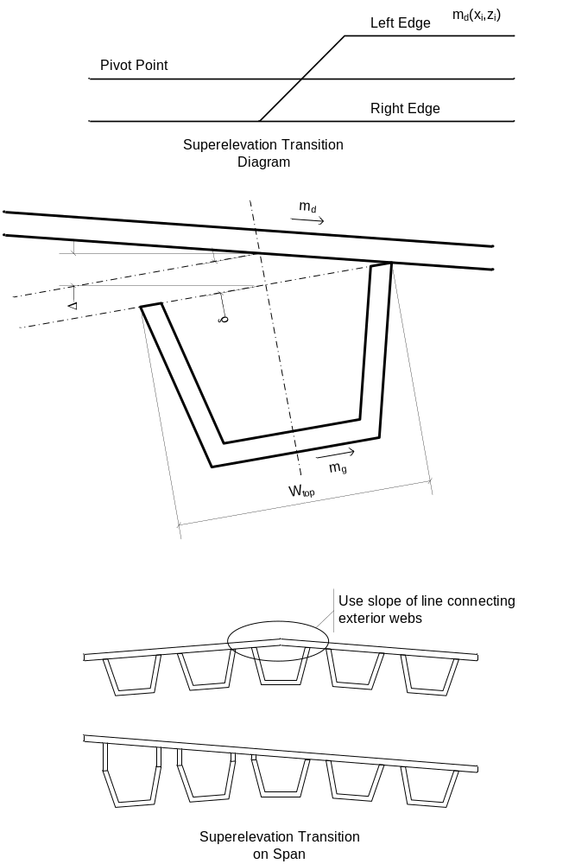
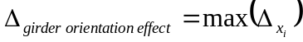
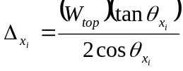
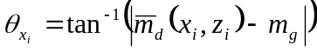
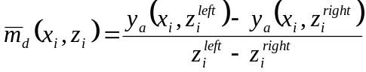
Where z_{i}^{left} = offset to left exterior mating surface and z_{i}^{right} = offset to right exterior mating surface

Girder Haunch
The girder haunch, measured at the intersection of the centerline of bearing and the centerline of girder is the sum of all these effects.

Limitations
These computations are for a single girder line. The required haunch should be determined for each girder line and the greatest used for all girder lines.

These computations are also limited to a single span. A different haunch may be needed at each end of a span. For example, if there is a long span next to a short span, the long span may have considerably more camber and will require a larger haunch. There is no need to have the shorter spans carry all the extra concrete needed to match the longer span (it is a waste of $$$). The shorter span could have a different haunch at each end.

